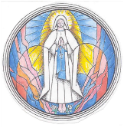
Middle School Youth Rally
Saturday, October 28th
Charlottesville Catholic High School
10:00am-5:00pm
(Carpool leaves OLL at 8:30am, returns at 6:30pm)

Payment – Please check one of the following:

_____ I am paying the $25 registration fee and have included it with this form.

_____ In addition to the registration fee, I would like to make an additional donation to the OLL Youth Ministry
Travel and Scholarship fund in the amount of $_____ and have included it with this form.

_____ I am requesting additional funding for this event. I am requesting an additional $_____in support and
have included the remaining $_____ with this form.

Student Name:

Parent Name: Parent Signature: Date:

